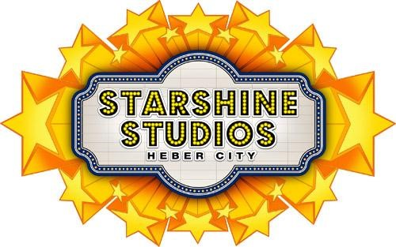Starshine Studios, LLC offers quality Performance Arts

instruction for boys and girls of all ages and abilities in a safe,

positive, and structured environment.

New This Season

10-week Class Programs

Program includes 10 weeks of instruction, class recital at the end of the session, performance costume, participation insurance, and Starshine Studios t-shirt.

Session 1: September 6th through November 17th

Monday 1:00-1:45 p.m. Mini Starz Gymnastics (3-5 years)

4:30-5:25 p.m. Tumble Starz (5 years & up)

Tuesday 10:00-10:45 a.m. Mighty Mini Starz Gymnastics (Director Approval)

10:45-11:30 Acting Up Mini Starz (3-5 years)

1:00-1:45 p.m. Exploring Dance Mini Starz (3-5 years)

4:15-5:10 p.m. Petite Ballet Stars (4-8 years)

Wednesday 4:15-5:10 p.m. Hip Hop Starz (4-8 years)

5:15-6:10 p.m. Jazz Starz (4-8 years)

6:15-7:10 p.m. Shooting Starz (leaps, turns, core) (8 years & up)

Thursday 10:00-10:45 a.m. Mighty Mini Starz Gymnastics (Director Approval)

10:45-11:30 a.m. Mini Starz Gymnastics (3-5 years)

4:15-5:10 p.m. Tap Starz (4-8 years)

Saturday 9:00-9:55 a.m. Tumble Starz 1 & 2 (5 years & up)

10:00-10:45 a.m. Mini Starz Gymnastics (3-5 years)

10:45-11:30 a.m. WEE Starz Gymnastics (18 months- 3 years)

Session Pricing:

1 Class/week for 10 weeks $185 2 Classes/week for 10 weeks $260

3 Classes/week for 10 weeks $330 4 Classes/week for 10 weeks $410

Tuition for multiple classes per week includes one t-shirt and one recital fee and includes participation insurance and costume for each class. 5 students are needed for the class to hold. Class sizes are limited to 10 students for Minis and 12 students for all other classes. Tuition is non-refundable and non-transferable unless class in cancelled by Starshine Studios.

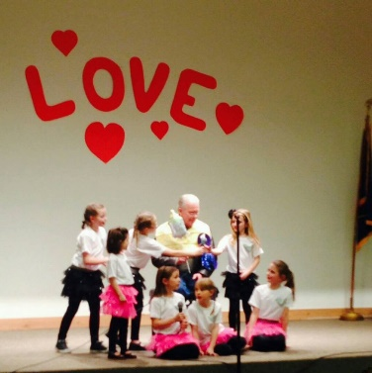

(801) 560-6699 [starshine.danceinfo@gmail.com](mailto:starshine.danceinfo@gmail.com)

Starshine Studios……

Where every child can SHINE!